Jared Callupe Lopez
DES360-B
Assignment 2 - Game Menu UI Redesign Pivot
Analysis
The selected game menu UI is Fortnite’s current main menu, with a focus on the ‘play’ tab. This is the screen you see right after the first loading screen which appears upon opening the game. This menu is composed of two main parts: the menu tabs, and the game mode library. The menu tabs guide the user through different menu categories like the ‘locker’ where they can customize their avatars, the ‘shop’ where they can buy cosmetic items, ‘battle pass’ where they can check progress on the current season’s battle pass, among other useful categories. These are aligned at the top left side of the screen, leaving space for the ‘social’ button to the right side. Right under, a news slideshow can be seen cycling through different tabs. At the bottom, the game modes library gets cut off by the edge of the screen, indicating the user is able to scroll down.
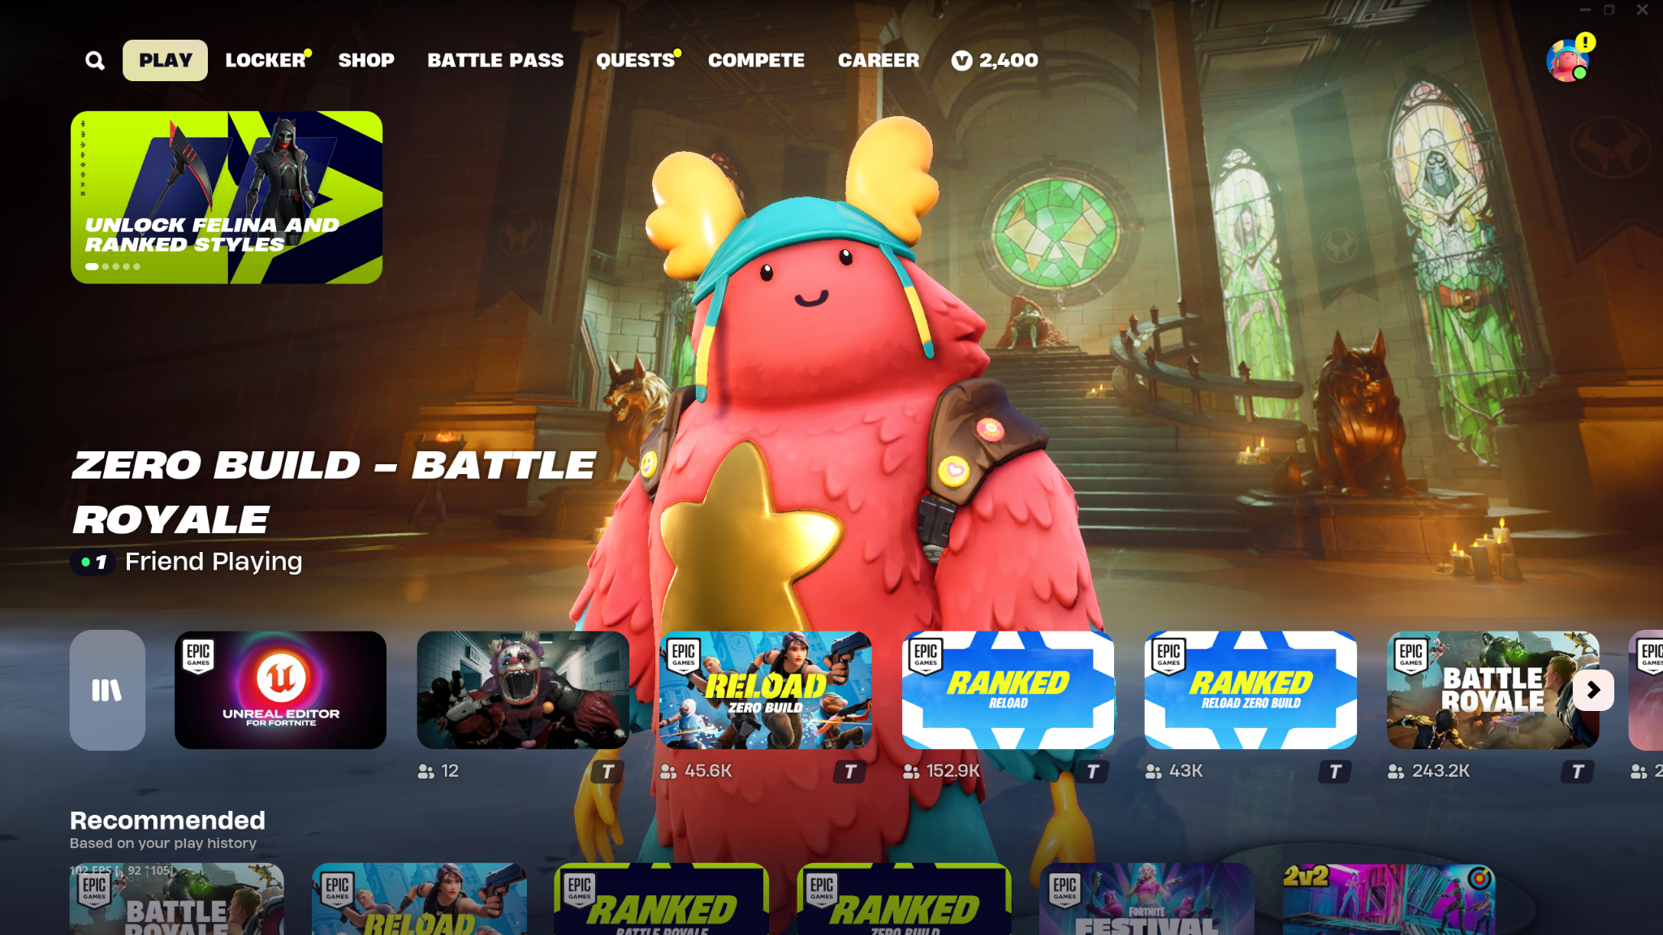
Fortnite’s Main Menu
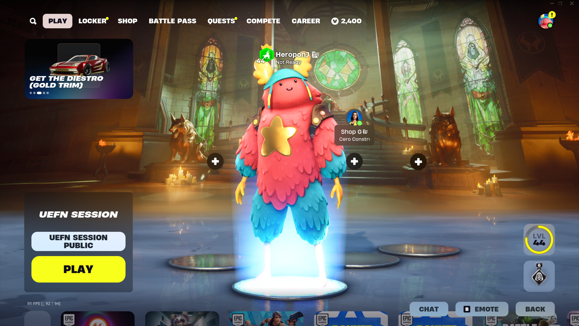
Fortnite’s Main Menu (game mode selected)
In order to understand why I picked this menu, I must explain my background as a user. I’m a Fortnite player who isn’t always active in the game, in other words, I play the game casually and take long breaks between active periods. For example, I’ll casually play for a week without worrying about the battle pass or performance in the game, then I’ll stop playing for multiple seasons, then come back and play some more, repeating this cycle. One of my biggest shocks one of the times I came back to the game was how much the main menu had changed. I remembered having no idea how to navigate it and thinking about how to go to the battle royale game mode as that’s what it’d be by default before that update. I think Epic Games insists a lot on their idea of Fortnite being a hub for different types of games. This has caused them to design the menu around the idea of hosting all of these game modes not everyone is interested in playing. The main intention for showing all these game modes upon opening the game is to further push this scheme and get players to try them out. However, several users agree that the menu is a mess, leaving millions of users dissatisfied with this design.
Pivot: Epic-Mickey
Earlier this year, Disney made a $1.5 billion equity stake in Epic Games, aiming to expand their influence in the metaverse and offer more immersive, interactive experiences with their intellectual properties. This investment matches Disney’s strategy to blend traditional entertainment with gaming, aimed towards younger audiences. Following this partnership, Disney has requested the addition of popular Disney character cosmetic outfits, such as those that have already been added from The Incredibles, Disney Villains, and The Nightmare Before Christmas. As well as dedicated Disney metaverse environments and game modes.
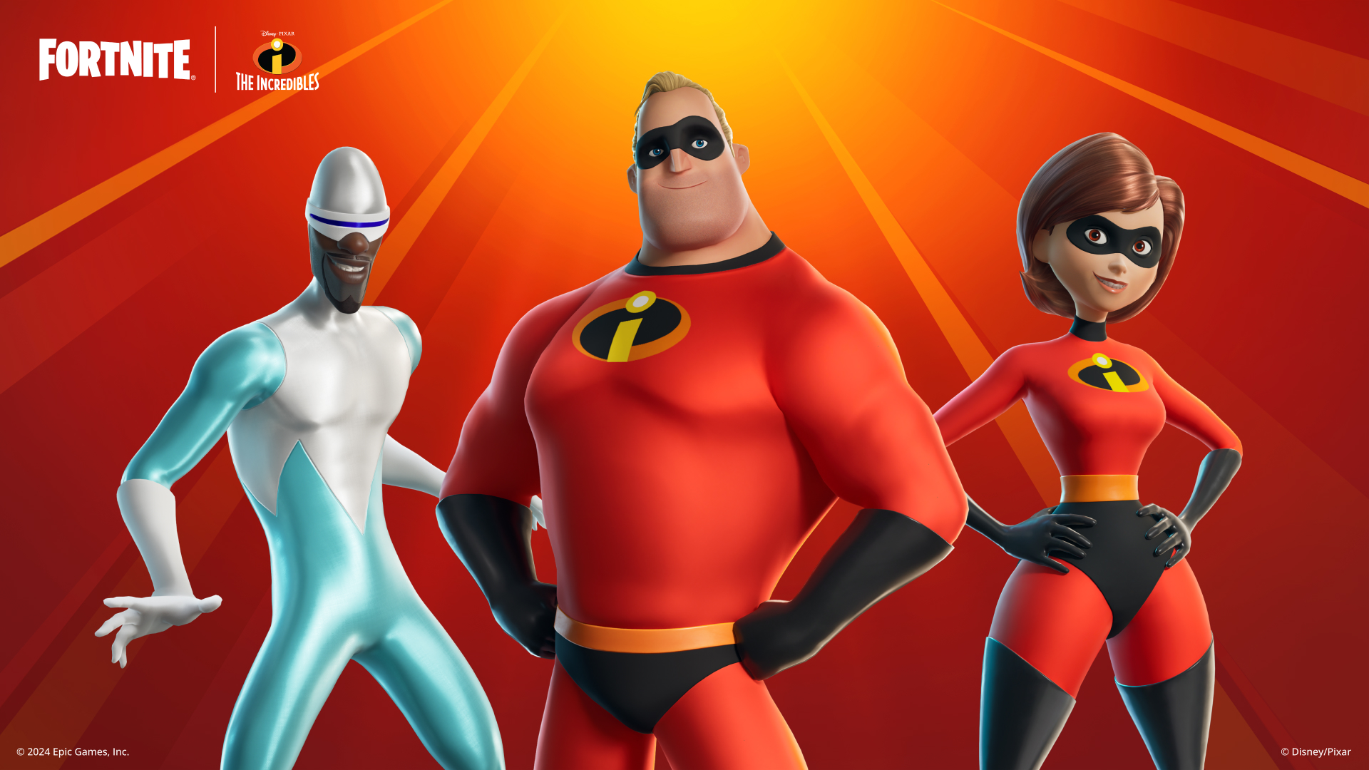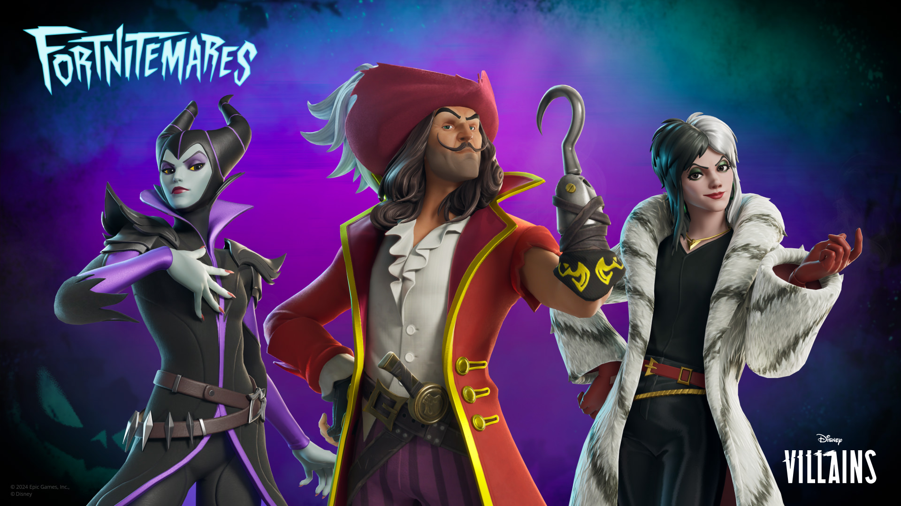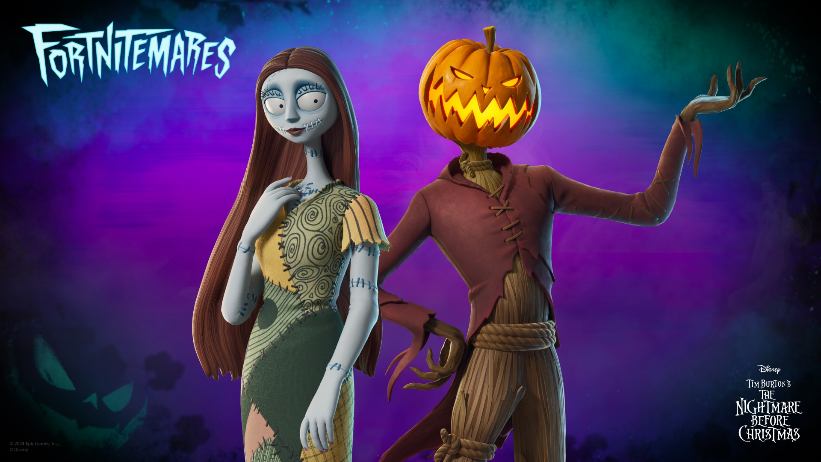
In order to satisfy the needs of Disney, the game’s Main Menu should accommodate these new features, fundamentally changing the design to fit a prominent Disney section alongside other core game modes. This will make Disney content immediately accessible and highly visible to all players. This new section should contain the following:
- Disney Game Modes: This option allows players to access the Disney Hub where they’ll find Disney-themed minigames, limited-time events, or experiences in general to attract both old and new fans.
- Dedicated Shop Area: This section also acts as a shortcut to the Disney section in the Item Shop, where players can purchase all of the different Disney character skins that have been released.
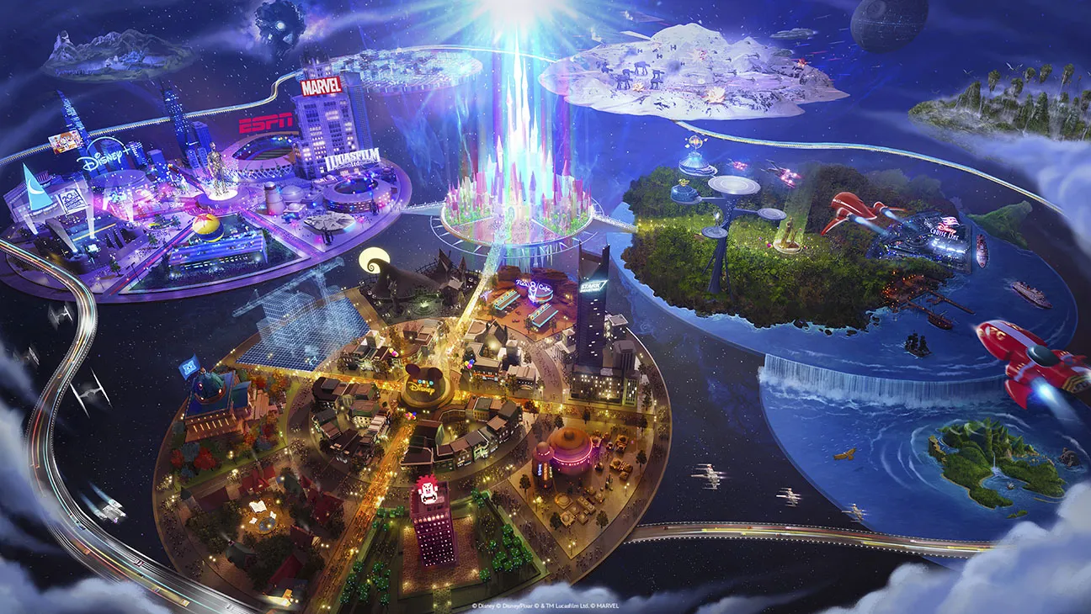
Disney’s metaverse vision
Research
In order to better understand the needs of the users, 6 different Fortnite users were interviewed, all with different backgrounds and goals in the game. In addition, a stakeholder was interviewed to see what the game needs from a accessibility and business standpoint. Brief descriptions of their personas will be explained along with short specifications regarding the meetings such as place and duration. Then, their player journey navigating the Main Menu UI will be described, accompanied by comments made by the interviewees as users. The average duration of user interviews was 7.6 minutes, while the stakeholder interview lasted 15 minutes. No ethical considerations to be made, as all participants are above the ESRB rating age. All interviewees consented to have their data collected and analyzed for this research.

User Interviews:
- User 1: Angel
Angel is a 22 year old full time college student. He’s a recurrent Fortnite player who plays every weekend in his free time. He started playing Fortnite Battle Royale 6 years ago, and has seen the evolution of the game in real time. On October 1st, he was interviewed online, through Discord, using the screen sharing feature for a total of 7 minutes.
Upon starting the game, Angel started looking for the Battle Royale game mode among all the other game modes like Lego, various Fall Guys game modes, and other Creative minigames. Since he plays more often, he claimed that the game modes are not always in the same order and that they might switch positions depending on which ones he played last, creating inconsistencies when looking for certain game modes. He said he wished the other ‘irrelevant’ minigames had their own ‘minigames’ tab at the top. He showed frustration as he mentioned that the same game modes appear several times in the library the more he scrolled. His final statement for the interview was that the majority of players are here for Battle Royale because that’s their bigger audience and how the game gained popularity, and that the minigames barely get played.
- User 2: Yasar
Yasar is a 23 year old college student with a part-time job. He’s also a recurrent Fortnite player who plays every other day when he’s not working. He started playing 7 years ago, when Battle Royale came out. On October 1st, he was interviewed online, through Discord, using the screen sharing feature for a total of 9 minutes.
As soon as the menu showed up, he said he wanted an option to go back to the previous menus since he didn’t feel too familiar with the new one still. He mentioned that, a week ago, he was queueing for a live tournament and the compete tab only had information regarding the event and leaderboard, but he couldn’t find where to play the actual tournament. He said he went to look for it in the play tab, but the game modes were cluttered with other ‘random’ game modes. Since it’s a live tournament, it is essential for players to queue as soon as it goes up because it lasts 3 hours which is just enough time for a player to complete the 10 games that you’re allowed to play in total.
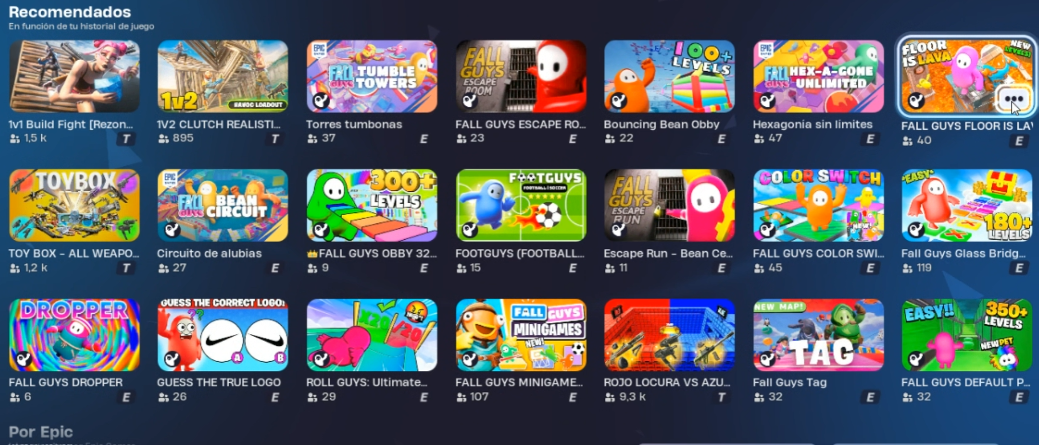
Screenshot of random games from Yasar
- User 3: Juan Carlos
Juan Carlos is a 20 year old college student. He’s been playing Fortnite Save The World since he can remember, as well as Battle Royale every now and then. On October 1st, he was interviewed online, through Discord, using the screen sharing feature for a total of 7 minutes.
Juan Carlos doesn’t like the fact that the menu for Save The World is very outdated and he’s expressed that he feels like Epic Games forgot about that game mode and its players. He argues that the missions and events of Save The World are the same every year, even the seasonal ones. He said he’s thankful that they revamped the locker menu, but everything else remains the same as the old Fortnite UI design. However, the locker menu update was part of a Battle Royale UI update, so he thinks that they barely put any effort into Save The World nowadays. He said it’s a game with lots of updates, but none of them go to their main project which was Save The World.
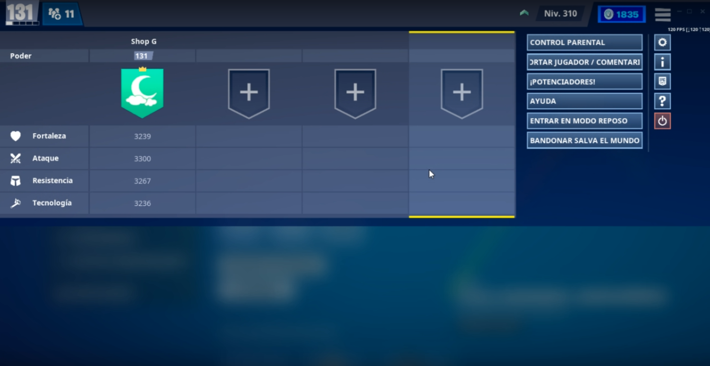
Screenshot of the old Fortnite UI in Save The World from Juan Carlos
- User 4: Isaac
Isaac is a 27 year old employed person. He started playing Fortnite when it came out on mobile, but he only plays when he gets invited by his friends. On October 2nd, he was interviewed online, through Discord, using the screen sharing feature for a total of 6 minutes.
Since he only plays when he’s invited, he mentions he never really learned how to navigate through the menus. Even if it’s a mobile port, he mentions that the icon size and layout isn’t properly adapted to a mobile resolution, so he plays on mobile with a controller as he finds playing with the screen very uncomfortable. One of his main complaints is that it’s hard to use the whisper feature because he cannot use the controller to type. He says he’d like to have a built-in keyboard for controller players that play on their mobile devices.
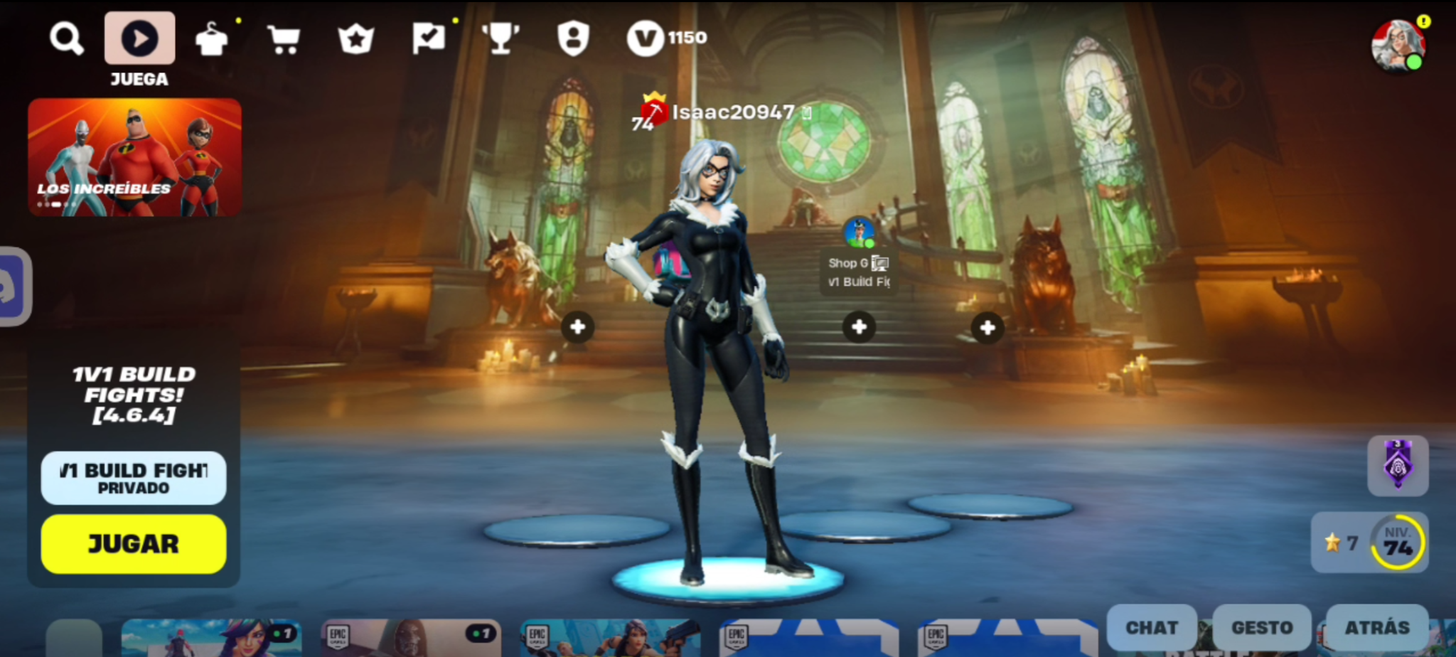
Fortnite’s mobile Main Menu from Isaac
- User 5: Evan
Evan is a 20 year old DigiPen RTIS student. He hasn’t played Fortnite since Battle Royale was released in 2017. He’s only familiar with Battle Royale duos, and he isn’t aware of any other game modes that came out recently. On October 2nd, he was interviewed in-person in Edison at DigiPen, for a total of 10 minutes.
His first impression upon seeing the main menu was confusion. He wanted to know how to join a match with friends like he used to do back when he played. He scrolled down the game mode library and he was astounded by the amount of creative game modes there were. He said it looked a lot like Roblox. He also mentioned that he wishes the main game modes, or Battle Royale, were at the top and the rest of the ‘Roblox’ game modes were right under. Surprisingly, after finding the Battle Royale game mode, he was able to navigate through the UI and change the mode from Solos to Duos.
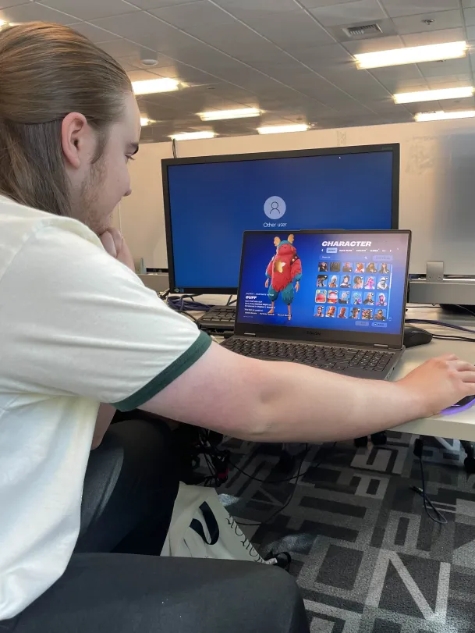
Evan inspecting further submenus
- User 6: Travis
Travis is a 21 year old DigiPen RTIS student. He used to play Fortnite a lot when it came out, but he stopped playing a few seasons after. He’s not aware of any updates the game has received since then. On October 2nd, he was interviewed in-person in Edison at DigiPen, for a total of 7 minutes.
Travis’ first comment was how he didn’t even know what he was supposed to do. The current main menu design was so foreign to his original concept of Fortnite Battle Royale that he didn’t know how to navigate the menu. After scrolling down, he made the same comment Evan did, that it looked like Roblox. After looking at all the different game modes, he scrolled back up and ran into the lobby screen, expressing surprise when he realized they kept the lobby 4 player slot layout. He was then interested in trying out the Lego game mode, but when he went to look for it, he said the library was a mess. He eventually found the game mode, but he still showed frustration after having to look for it among all the other creative game modes.
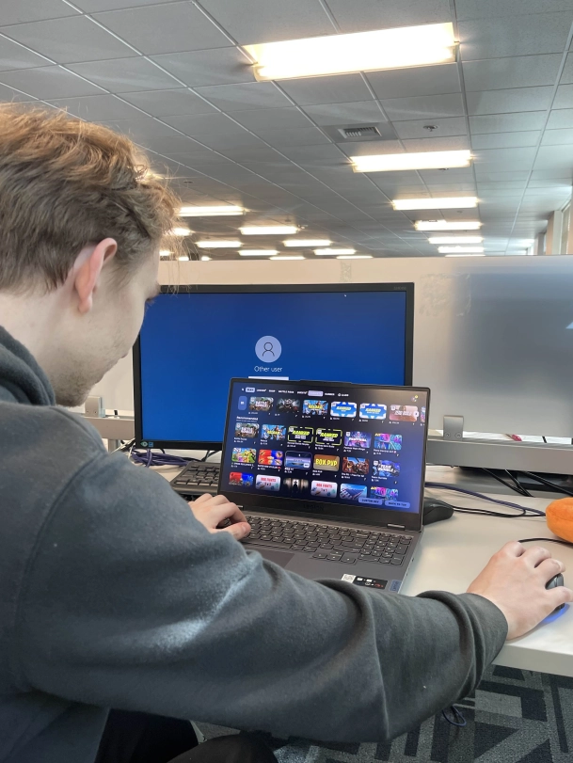
Travis looking at the game mode library

Stakeholder Interview:
- Stakeholder: Joshua D. Savage
Joshua D. Savage is a Professor at DigiPen Institute of Technology. He’s only played one single game of Fortnite before, when it came out on the Nintendo Switch. For the sake of this research, he’ll be playing the role of a stakeholder who’s barely been involved in development, but his opinions still have a lot of weight at the moment of making decisions regarding the game’s design. In this interview, we’ll be reviewing the design of Fortnite’s Main Menu. However, they have some personal biases when it comes to accessibility features and monetization. Therefore, they were asked to be as biased as possible, avoiding more objective feedback on the UI design. On October 4th, he was interviewed in-person in Tesla at DigiPen, for a total of 15 minutes.
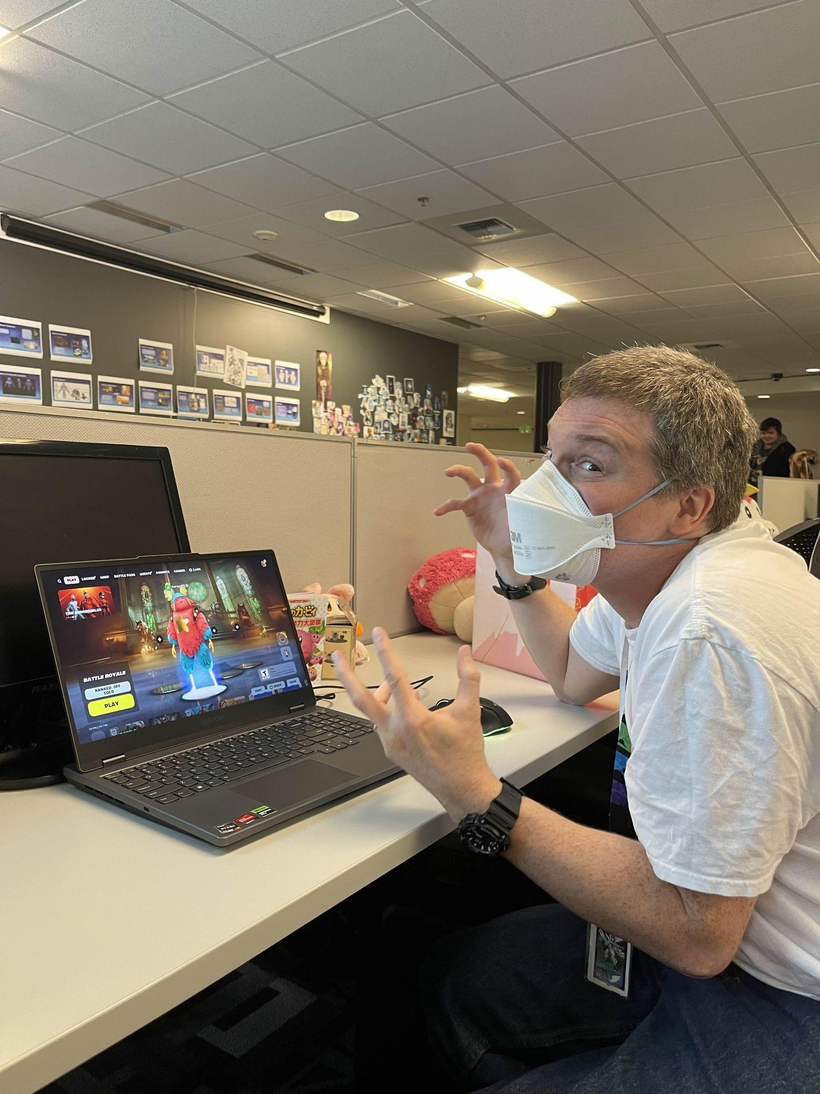
After asking some basic introduction questions, the game finished loading. Stakeholder Savage already had many questions upon seeing the Main Menu show up: “How do I join?”, “Where’s the game?”, “ Who am I?”, “Let me play!”. He showed a lot of confusion while looking through the different game modes, so he continued by scrolling up and looking at the other tabs. When looking at the compete tab, he noticed how some events reward players with prize money, so they insisted that this tab should be easier to access as he couldn’t tell how to enter a tournament to compete in. In the battle pass tab, they liked the way it was presented, but he asked how ranking up the battle pass affected gameplay as they want people to spend more money on it. One observation he made was how, when attempting to buy the battle pass, he didn’t know if it used the same currency as the one that appeared on the top right, as they had a different icon. In the quests tab, while looking at a quest that makes the player play the game on mobile, he mentioned that’s great, as we want more people to play the game on mobile. Though, he said that all limited quests must be at the top of the list due to their exclusive nature. In the shop tab, he scrolled down while looking at the different offers for different skins, amazed by the amount of different collaborations the game had with a wide number of intellectual properties. He mentioned that while it’s great that people have a lot to spend on, the shop menu is very unorganized and requires a redesign. In the V-Bucks tab, his first impression was that it looked boring and that we want players to spend more so the design needs to be more dynamic and flashy. After looking through some other tabs, he mentioned: “My biggest question is what the heck is this?” while pointing at the play tab menu. He claimed there’s too much information given to the player, and mocked its resemblance to a YouTube homepage. They commented on the way the game modes are organized: “Why do I have to go down? Give me broad categories! Recently uploaded is not a category!”, “Where do I see what I’m playing?”, and “YouTube is more organized than this!”
Nonetheless, Stakeholder Savage applauded some of the accessibility features the game has in the menus. For instance, in the settings menu, in the video tab, he found out that players are able to select a color blind mode depending on what type of color blindness they have. For context, Stakeholder Savage has deuteranopia which makes it difficult to distinguish between red and green colors, as well as yellow and bright green colors. This feature allowed them to differentiate the colors better and he even praised the addition of a color blindness test in the UI itself, as well as a color blind strength setting. Another example of Stakeholder Savage pushing for accessibility is having the ESRB rating of every game mode available in the lobby screen. Furthermore, he appreciated the fact that you’re able to click on the rating and it’ll send you to a ratings guide website to inform parents about the content their kids are consuming, which is great to avoid lawsuits from parents who didn’t check the game mode’s age rating. However, he did mention that there needs to be more regulation regarding content creation as some of the game modes in the library aren’t properly licensed.

Based on these 6 user interviews and stakeholder interview, we were able to get enough feedback to identify common problems in the UI design across multiple kinds of users. Among some of the main issues with the Main Menu UI design we can find inconsistencies with the way the game modes are categorized, players wishing the game modes that are not part of Battle Royale were moved to a different tab, players wanting the old menus back, difficulty when finding game modes due to clutter in the game mode library, inconsistencies in menu UI for Save The world, resemblance to game platforms like Roblox, overall messy design in the game mode library, competitive game modes being hard to access, unorganized shop menu, game mode library’s resemblance to a YouTube homepage, among others.
Design
Now that we know some of the pain points the Main Menu UI has, we are able to identify problem statements that will help us come up with solutions that are going to improve the design of the Main Menu UI.
Problem Statements:
- Problem Statement 1: “Cluttered game mode library organization leads to confusion for players navigating the menu”.
  - Solution 1: One solution to avoid clutter in one single game mode library is separating game modes into clear, broader categories. This would be similar to the previous game mode select screen that would appear upon opening the game, separating the game in the three main modes it had back then. This would allow for easier and more consistent navigation, reducing frustration for players who find the current structure disorganized.
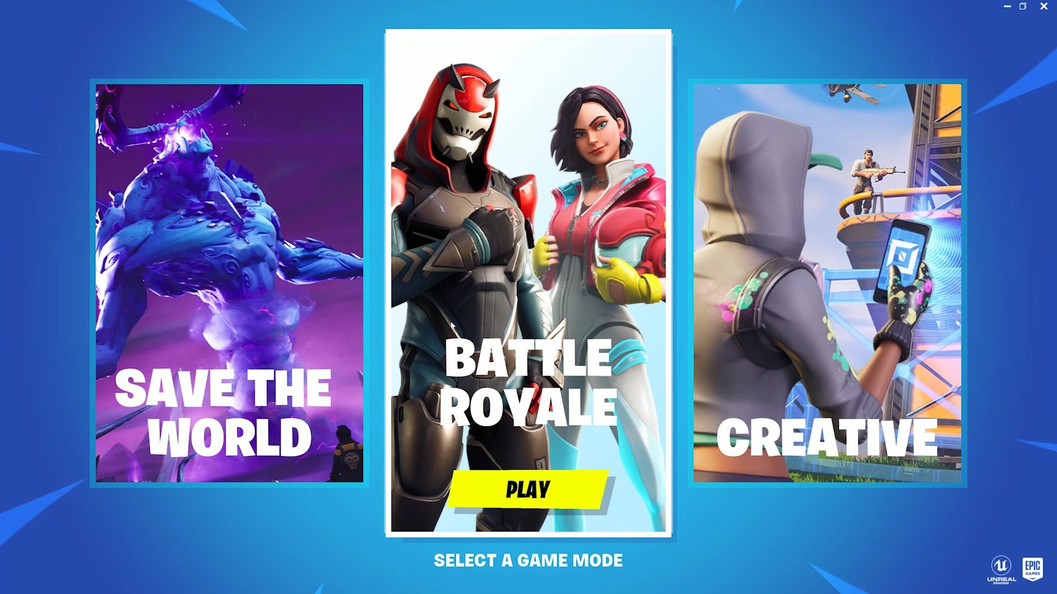
https://interfaceingame.com/wp-content/uploads/fortnite/fortnite-select-mode.mp4
  - Solution 2: Another solution would be to follow a mode selection similar to Apex Legends’, where players can open up an overlay that presents the main game modes separated in 3 different sections: Ranked, Arenas, and the current Event game mode. The interface will be divided in Battle Royale, Save the World, Minigames, Fortnite Festival, and Lego. To avoid clutter, the minigames game mode opens up a second overlay that allows the player to select a creative game mode. The player will have multiple slots for their favorite creative game modes. This will allow the player to rapidly navigate this interface without having to look through hundreds of game modes they’re not interested in.
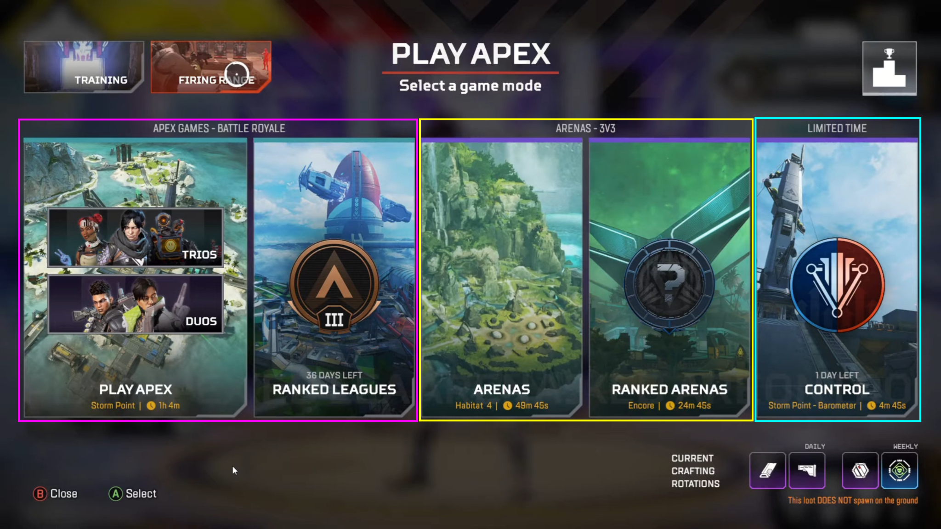
How to navigate the Menu in Apex Legends (youtube.com)
- Problem Statement 2: “The game mode library lacks clear organization and categorization, making it difficult for players to find relevant content”.
  - Solution 1: Redesign the structure of the game mode library by adding tabs at the top of the list divided in: Trending, Popular, Recently uploaded, and others. This will allow users to quickly switch between interests, maintaining organization as they explore new content.
  - Solution 2: A similar game that has a huge library of games is Roblox. They handle the variety of game modes by providing curated categories, filters and recommendations based on the user’s activity. Fortnite could adopt this approach and create an algorithm that recommends the player game modes based on the ones they play regularly. This will allow players to find new content while keeping the experience personalized and organized.
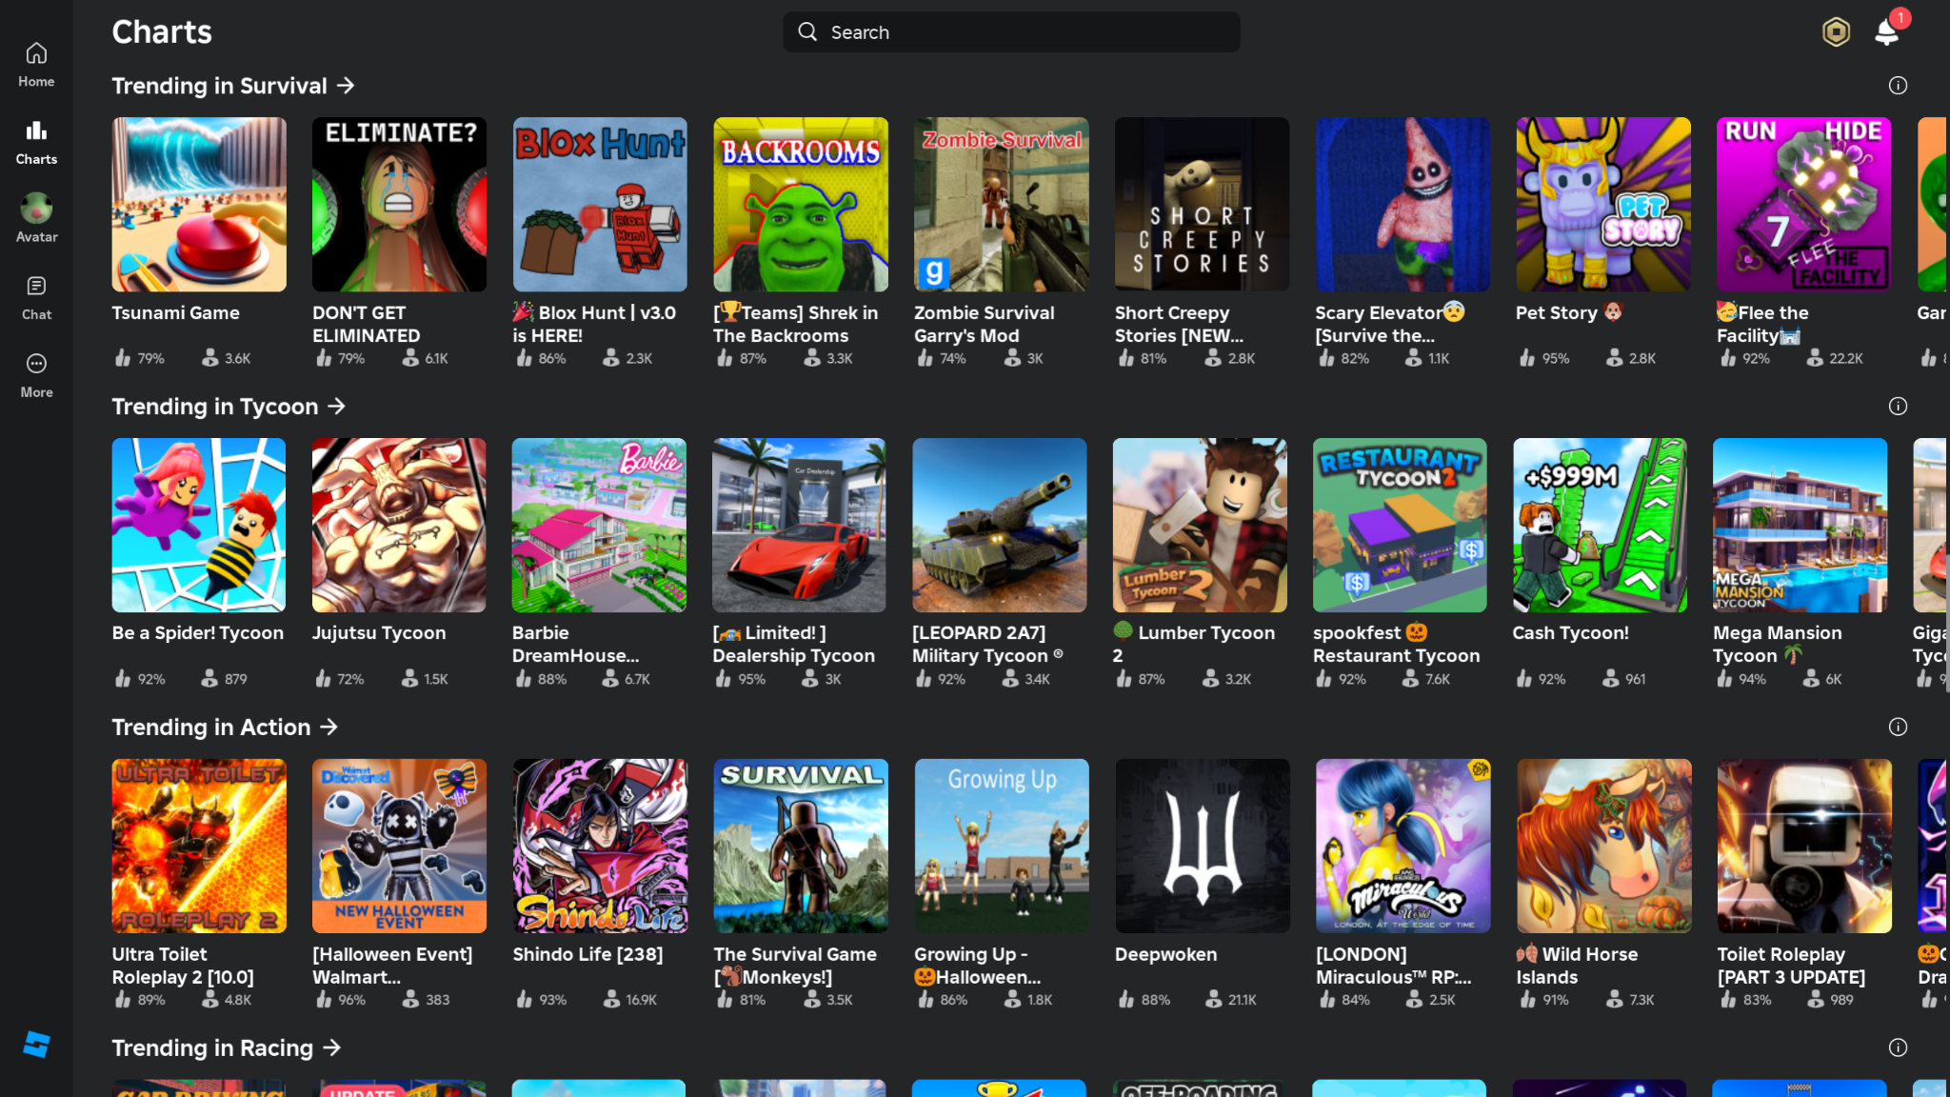
Roblox’s different curated categories
- Problem Statement 3: “Poor visual design in the V-Bucks tab impacts user experience, affecting potential for higher sales”.
  - Solution 1: Update the design of the V-Bucks tab with more dynamic and visually engaging graphics and animations. Having a recurrent limited time discounted deal that changes every certain period of time would encourage higher spending. They used to do something similar back in previous seasons by showcasing an exclusive skin in the V-Bucks tab that will change every season, making the purchase of premium currency more enticing for players.
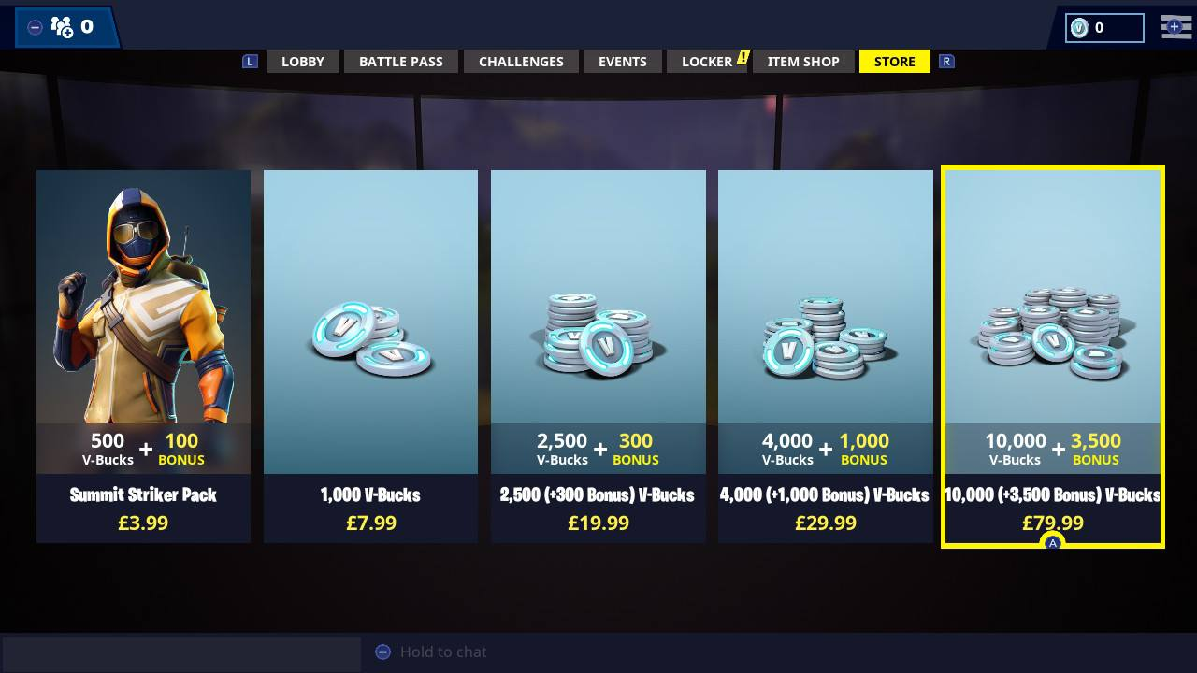
How Much Does It Cost to Buy Everything In Fortnite? – New Normative
  - Solution 2: Add incentives to buying premium currency by providing additional value to purchasable packs. In Honkai Star Rail, players who buy premium currency, called Genesis Crystals, receive additional currency, creating a bigger incentive for players to spend on these packs. In Fortnite, bonus V-Bucks could be offered when players purchase specific packs. This should be done by displaying these bonuses with dynamic visuals and graphics. This will result in a sense of value and urgency, improving sales.
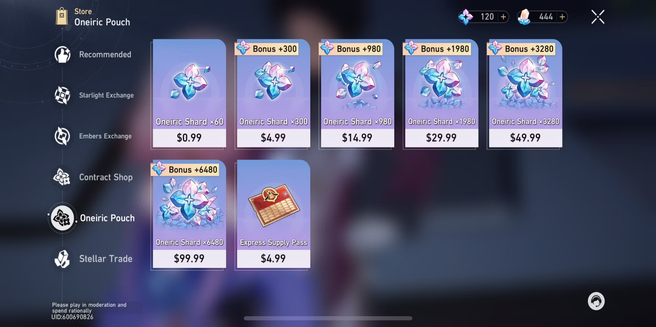
Honkai Star Rail: Currency Guide (dualshockers.com)
Solution Spec
- Problem Statement: “Cluttered game mode library organization leads to confusion for players navigating the menu”.
- Target User: There’s four main user groups that this design will target:
  - Frequent Fortnite players who often return to Battle Royale but struggle with clutter in the game mode library screen.
  - Competitive players who engage in live tournaments or competitions, which require quick and reliable access to game modes.
  - Returning players who find the overwhelming number of creative modes confusing and disorienting.
  - Disney fans, both old fans and new users interested in Disney in-game content.
The first three types of users enjoy the core Battle Royale game mode, but they have expressed their frustration with finding it due to clutter from the many other creative game modes in the game mode library. For all of them, the ability to quickly access a game mode is essential for retaining engagement.
- Design principles:
  - Visual Clarity: Reduce visual clutter by creating clear and concise categories, making it easier for players to find specific game modes in the library. All of this, while having a clearly marked Disney section with the appropriate branding to capture player interest.
  - User-Centric Organization: Prioritize frequently played and Battle Royale game modes by keeping them visible at the top of the list or in the main interface, also ensuring Disney content is accessible from the main screen, but positioned to avoid crowding other core game modes.
  - Consistency: Ensure game modes remain in a consistent position and scale so users develop muscle memory when navigating the menu, keeping the Disney section cohesive while drawing attention to new Disney updates and items.
- Proposal: The main menu will start in the lobby screen, as it used to do in the Battle Royale game mode. At the bottom left, where the current game mode settings are located, players will be able to click on the game mode and change it from there, instead of having a list they can scroll down to at the bottom of their screen. When clicked, the game will instantiate an overlay that contains all the main game modes the game offers, as well as minigames players have marked as favorite. In the middle left, both main Battle Royale game modes can be found: unranked and ranked. These two occupy about 30% of the width of the whole menu as these are the most relevant game modes, and the ones people look the most for. In the middle right, we have the “secondary” or “not as relevant but official” game modes such as Fortnite Festival, Save the World, and Lego Fortnite. When hovered over, these game modes, along with the main ones, will pop out and play short animations to invite the player to play them. On the far left, we can find the dedicated Disney section, where all Disney-related content will be displayed to the player. At the top, we can find multiple featured skins, as well as a shortcut button players can use to automatically be brought to the Disney section in the item shop. At the bottom, we can find the main Disney Hub, which is its own dedicated game mode where players will be able to find all Disney-related game modes. Finally, we have the minigames section, which was one of the naming suggestions from one of the interviewees. This section will showcase a list of all of the user’s game modes marked as favorite. If the user has no game modes set as favorite, it will show a list of suggestions based on the algorithm implemented. At the bottom of this section, 3 buttons can be found: social, discovery, and search. Social allows the player to see game modes that are popular among their friends or the most played if the player has no friends that play minigames. Discovery displays a list of all minigames, similar to the current design but with a dedicated menu to it. Finally, Search will allow players to look for games based on keywords or curated category tags. When selected, these game modes will bring the player back to the lobby screen where they can change the game settings such as privacy and number of players. This way, the game can continue developing its idea of being a hub for different types of games, while staying organized and keeping a hierarchy with its main game modes. This also takes into account the hierarchy of core game modes, putting them right in the middle with more vibrant colors, while having less relevant content on the sides of the screen.
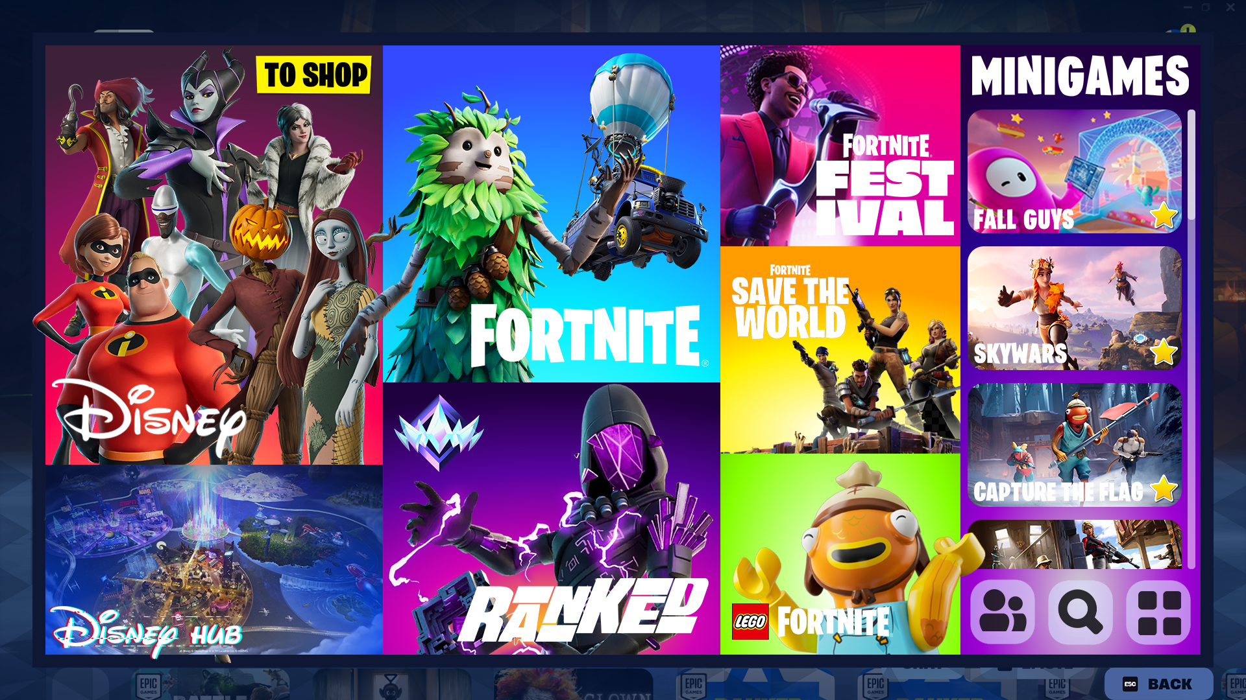
Play tab mockup (assets extracted from Beyond Fortnite Assets)
- Production Constraints:
  - Timeline: The time that it’ll take to implement this design in the game would be around the duration of one Fortnite season which lasts approximately 10 weeks depending on various factors. This way, the design can be implemented for the next season or the one right after. The production of this menu, assuming previous User Research has already been complete, will be divided in:
    - Design (3 weeks): Designers and a Disney imagineer will be given time for brainstorming, creating mockups and wireframes, and performing internal testing.
    - Implementation (3 weeks): Once the design team has pitched their design, programmers will take care of implementing the UI changes. About 3 weeks of development will be given to create the appropriate changes.
    - QA and Playtesting (4 weeks): The design team and QA testers will run playtests for the new menu to ensure this new layout satisfies players’ needs. Programmers will both make sure the new menu works on all devices, and make changes to the product based on QA testing.
    - Launch: The main menu is ready for launch, and will be implemented in the following season.
  - People Needed:
    - UX/UI Designers (2): Designers to sketch, mockup, iterate, and finalize the new Main Menu UI structure. They’ll be making further design decisions throughout production. One of them will be the lead that oversees the production of this new Main Menu.
    - Disney Imagineer (1): A Disney imagineer in charge of all design aspects related to the Disney brand. They’ll be working in the design team to make sure this new design fits the different criteria Disney establishes. Additionally, they’ll serve as a Disney ambassador to assist the rest of the team with any question they might have during development.
    - Programmers (3): Developers to build a prototype of the designers’ vision and further polish by making the required UI elements. In addition, they’ll develop the different categories feature, as well as the algorithm that will decide what games to recommend to the player.
    - QA Testers (2): Testers to ensure the new Main Menu works across various devices and to help conduct playtests with designers.
  - Cost Estimate: Considering the average base salary for game developers in the US is 115,000 USD per year (2024 Game Developer Salary in US | Built In), or around 9,500 USD per month, that totals to 66,500 USD per month for this team of 7 game developers. Considering this production process will last about 2.5 months, then a rough estimate of the cost goes up to 166,250 USD for 10 weeks of production for the team of game developers. Regarding the salary of the Disney Imagineer, we must consider that the median total pay for a Walt Disney Company Imagineer is 93,000 USD per year (Walt Disney Company Imagineer Salaries | Glassdoor). This translates to around 7,750 USD per month, or 19,375 USD for 10 weeks of production. In total, an average of 185,625 USD will be the cost of this Main Menu Redesign Project, accounting for the salary of 7 Game Developers and 1 Disney Imagineer.
- Benefits:
  - Improved UX/UI: Players will have a smoother and more intuitive experience when navigating the Main Menu. People who play Battle Royale more frequently will feel less overwhelmed by the current layout. This will help retain engagement in both long-term and returning players.
  - Retention of Returning Players: Players who have not played for some time will find the new menu easier to understand and less overwhelming than the current one. This will highly improve the chances of them returning to the game and staying engaged for longer periods.
  - Scalability for Future Updates: Due to the ever-growing nature of Fortnite, it’ll be easier to introduce new game modes and events. This new structure will accommodate future additions without cluttering the user interface.
  - Brand Reinforcement: Featuring Disney content in the main menu reinforces their association with the game, making them more memorable and encouraging loyalty in newer fans and potentially newer demographics.
Results
Some of the previous interviewees were interviewed again to collect feedback regarding this new menu layout. Additionally, these people were asked about their opinion on the new redesign based around the Epic-Mickey pivot.
- User 1: Angel
Angel mentioned his first impression was that the icons were too big, especially for a computer monitor. However, he liked the different colors that differentiated each game mode. He added that it’d be a fun idea if the skins showcased on each game mode changed depending on the current holiday or seasonal battle pass skins.
- User 2: Yasar
Upon seeing the mockup, Yasar mentioned that he really liked how the ranked section showed the icon of your current rank in the game mode. However, he didn’t like how it took up too much space on the screen.
- User 3: Juan Carlos
His first thought was how it looks a lot more like a mobile game menu. When asked why, he said the letters and logos are too big at times making the overall sections appear bigger. He also mentioned it could be fixed by reducing the size of the overall menu or making margins between each section.
- User 4: Isaac
Since Isaac plays on mobile, he said it’s nice that the icons fit on a mobile display. He even mentioned feeling like he was able to just tap on the screen and select a game mode in-game. He said that one thing that could be done to fix it was taking off the minigames section and putting a dedicated favorites section, but after mentioning how this section works, he said that it works better, but he’d still like it to be labeled as ‘Favorites’.
- User 5: Evan
Evan said he liked that the game modes he personally wants to play when he opens Fortnite are in the middle on the menu. Another thing he mentioned is that he doesn’t really play the ranked game mode, but it’d be cool if both regular and ranked game modes had submenus to pick between build or no build modes. He thinks the Disney section having a shop button is infuriating, and that it makes his blood boil. Regarding the Disney Hub, he’s not sure what it’s for, but he assumed it’s a submenu for more Disney game modes.
- User 6: Travis
Travis mentioned that it’s good that the main ‘Fortnite’ game mode is in the middle, for when he plays Battle Royale. He added that he especially liked the minigames section and how it was a list that contained your favorite game modes outside Battle Royale. However, he said that the Disney section did feel like an ad, he even pointed out the ‘to shop’ button next to the skins.
- Stakeholder: Joshua D. Savage
Stakeholder Savage was also able to share his thoughts on this new main menu redesign. Upon seeing the new mockup, he mentioned that it was immediately a great improvement over the old messy YouTube carousel menu. They can instantly tell where each option takes them and what they’re supposed to do. He said that he found it easy to spot most game modes and the different options at a glance. Regarding what they’d like to see fixed on the next iteration, he pointed out that it looked like only the Disney section was featuring their skins, while the Fortnite ones felt neglected. Regarding the ‘to shop’ button itself, they weren’t able to tell whether it was its own button or the entire top left section was the button. They added that the ‘shop’ text should be bigger. They also shared their concerns regarding the identity of both brands, as right now ‘Disney’ and ‘Fortnite’ look like two separate products. He suggested the attachment of the ‘Fortnite’ label to Disney content. One feature he praised was the Disney Hub being its own dedicated section for all Disney-related game modes. Finally, he only had a doubt regarding the purpose of the four little squares in the bottom right icon. Overall, they seemed pretty pleased with the layout, especially from a stakeholder standpoint.
Based on these results, users applauded the improved navigation in and straightforward access to the core Fortnite game modes like Battle Royale, effectively reducing the clutter and confusion from the old main menu. The Disney section was particularly interesting. While most users found it appealing for its visuals and the overall theme of the content, some mentioned that it felt too promotional, almost like an advertisement, which minimizes the immersive experience. For future updates, users suggested that visuals, like outfit sprites, could change to match different seasonal events throughout the year. Having a skeleton outfit featured on the main Battle Royale game mode during Halloween, for example. This would fix some of the concerns presented by Stakeholder Savage regarding Disney outfits being the only ones featured. Some users suggested a change in the scale of the menu itself as they thought it was too big for a monitor screen. Nonetheless, one mobile player appreciated the bigger buttons for the menu layout. Others proposed more personalization options for this screen, making the layout more adaptable to individual playstyles and interests. Overall, the new design for the main menu has successfully addressed major navigation issues from the previous layout, creating a more navigable and visually engaging experience.

